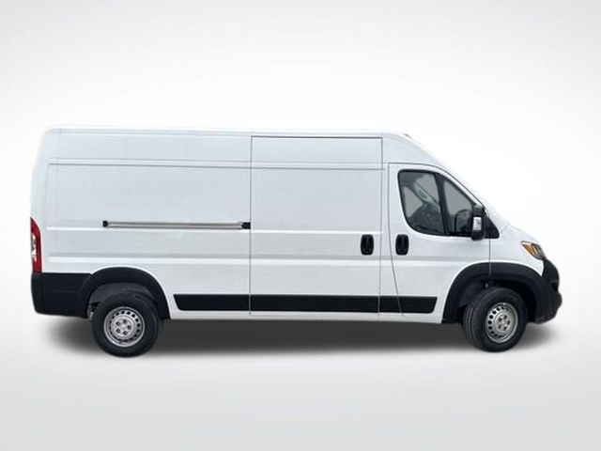
Battery
Auxiliary Battery Location – Battery can be accessed from passenger side exterior, underneath van adjacent to front of rear axle.

