Winterizing Lithium Phosphate Battery
- Charge auxiliary battery between 80-100% via 115V shoreline plug.
- Disconnect positive and negative battery cable from auxiliary battery underneath van
- Tape positive and negative battery cable end/lugs utilizing electrical tape
“Springtime” Reconnecting Lithium Phosphate Battery
- Remove electrical tape from battery cable end/lugs
- Reconnect positive and negative battery cables to auxiliary battery
- Charge auxiliary battery via 115V shoreline plug to 100% - Note temperature must be at least 32 Degrees Fahrenheit for battery to charge properly. Do not attempt to charge battery when temperature is below 32 Degrees Fahrenheit.
Battery Terminals
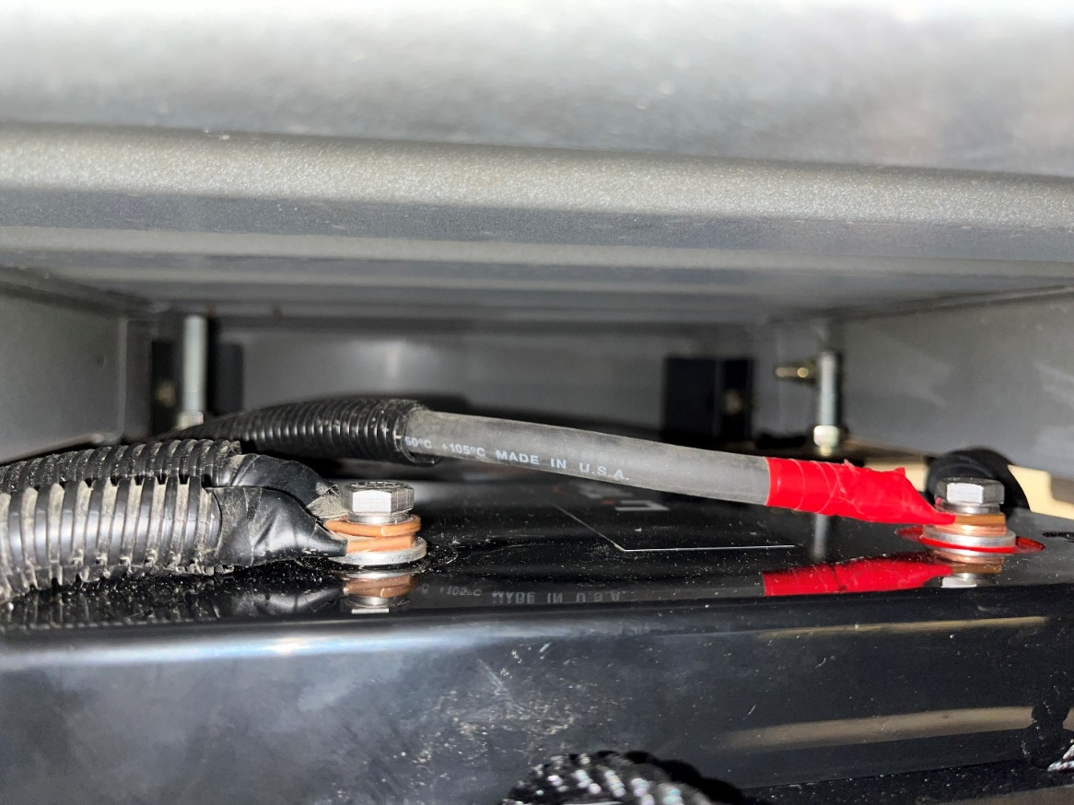
POSITIVE - RED

NEGATIVE- BLACK

